## Higher National Diploma in Information Technology

**Object Oriented Programming**

**Lab Sheet 04**

1. Declares an int named week whose value represents a day out of the week. The program should displays the name of the day, based on the value of week, using the switch statement.
2. Write a simple menu driven java program to select the city guide. In this program user can select the city by typing first letter of the city and according to that user input your program display the Name of the city and Guide book no .

**Choices**

C --🡪 Colombo

K🡪 Kandy

G🡪 Galle

If user select “C” print Colombo: Booklet 1

If user select “K” print Kandy: Booklet 2

If user select “G” print Galle: Booklet 3

1. Write a java program to print “Hello world” infinite times?
2. Write a simple program to describe your Grade

**Grade description**

**A Excellent**

**B/C Well done**

**D You passed**

**F Better try again**

**Any other Invalid grade**

Hint: - if user passes F as his or her Grade your program will display **“Better try again”**

1. Modify your program to get the users Grade as a key board input and display the description.
2. Write program to get the two numbers as key board input and users can select the operation using menu

Choice 1 🡪 for Add two numbers

Choice 2 🡪 For Subtract two numbers

Choice 3 🡪 for Multiply two numbers

Choice 4 🡪 for Division two numbers

1. Write a java program to get the following output?

Hint: use %,*,/ , do- while loop

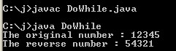

1. Write a simple java program using while loop to display the table of 2

Output should be like this

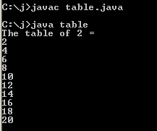

1. Write an application that inputs one number consisting of five digits from the user, separates the number into its individual digits and prints the digits separated from one another by three spaces each. For example, if the user types in the number **42339**, the program should print

